6th Grade Book List 2021-2022
(6th grade cannot use digital books)

Bible 6
Route 66
Author: Reed
Publisher: Positive Action for Christ
2006 Edition
ISBN#: 9781595571090
Required (must be purchased new)
Will use for 6th,7th, and 8th grade

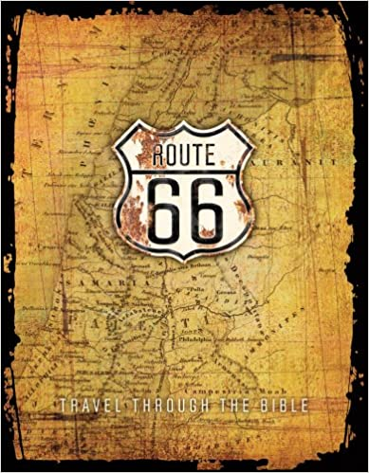

Humanities 6

The Lion, the Witch and the Wardrobe
Author: Lewis
Publisher: Harper Collins
Edition: 1978
ISBN# 9780064404990
Required-Summer Reading
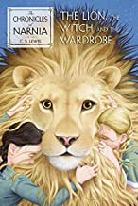

Old World History and Geography in Christian Perspective
Author: Abeka
Publisher: Abeka
Edition: 2012
Item # 135275
Required
Purchase item on abeka.com

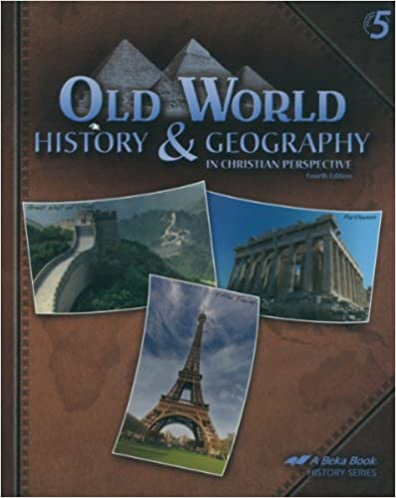

The Brook Hill Writing Guide
Author: Travis
ISBN# 978-1475225761
Required –will use grades 6th-12th

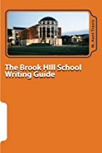

Eric Liddell: Something Greater than Gold
Author: Benge
Publisher: YWAM Publishing
ISBN# 9781576581377
Required

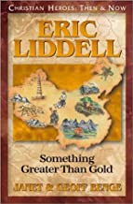

The Shadow Club
Author: Shusterman
Publisher: Random House, Inc.
Edition: 2002
ISBN# 9780142300947
Required
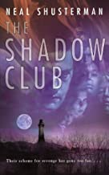

The Giver
Author: Lowry
ISBN# 9780544340688
Required
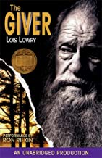

The Bronze Bow
Author: Speare
Publisher: Houghton Mifflin
Edition: 1961
ISBN# 9780395137192
Required

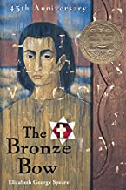

The Lightening Thief (Percy Jackson)
Author: Riordan
Publisher: Hyperion Books for Children
Edition: 2005
ISBN# 9780786838653
Required
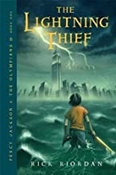

**Each 6th grade student will have a $10 fee added to their FACTS account. This will cover the vocabulary book that will be given to the student.

Math 6

Big Ideas Math Advanced 1: A Bridge to Success
Author: Larson
Publisher: Houghton Mifflin
ISBN# 9781680331288
2014
Required plus $20 access code. The $20 will be added to your FACTS account.
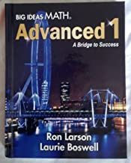

Science 6

Earth Science
Author: Elmer/Ferrier
Publisher: Christian Schools International
ISBN#: 9780874630237
Required

