7th Grade Book List 2021-2022
(7th grade can use digital books)

Bible 7
Route 66
Author: Reed
Publisher: Positive Action for Christ
2006 Edition
Hard copy version-must be new or used by the student in Bible 6.
ISBN#: 9781595571090
or
Digital version
https://positiveaction.org/store/group/route-66
Student Manual-digital (PDF)
Required

This is the same book used in Bible 6. It will also be used in Bible 8.

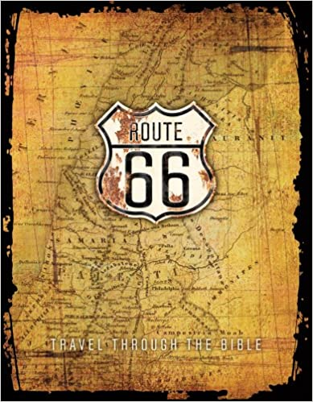

Humanities 7
The Hobbit
Author: Tolkien
Publisher: Houghton Mifflin
Edition: 2012
ISBN# 9780547928227
Required-Summer Reading
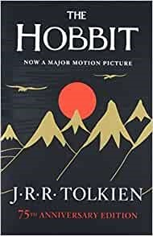

Texas History, Grade 7
Publisher: McGraw Hill
ISBN#: 9780076612710
Required
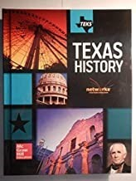

The Brook Hill Writing Guide
Author: Travis
ISBN#: 978-1475225761
Required-will use grades 6th-12th
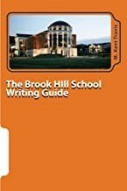

The Girl Who Owned a City
Author: Nelson
Publisher: Lerner Publications
Edition: 1995
ISBN#: 9780761350866
Required

Where the Broken Heart Still Beats
Author: Meyer
Publisher: Harcourt Trade Products
Edition: 1992
ISBN#: 9780152956028
Required

Freak the Mighty
Author: Philbrick
Publisher: Scholastic Inc.
Edition: 1993
ISBN#: 9780439286060
Required
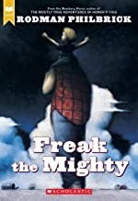

Dark Water Rising
Author: Hail
Publisher: MPS
Edition: 2010
ISBN#: 9780312629083
Required
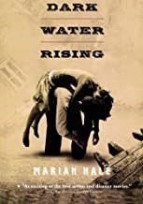

**Each 7th grade student will have a $10 fee added to their FACTS account. This will cover the vocabulary book that will be given to the student.

Math 7
**$20 access code that includes an eTextbook. The $20 will be added to your FACTS account.

OPTIONAL (hard copy)
Big Ideas Math Advanced 2: A Bridge to Success
Author: Larson
Publisher: Houghton Mifflin
ISBN#: 9781680331301

(*If student takes a more advanced Math, please check US Math listing to order correct book or contact Academic Office.)
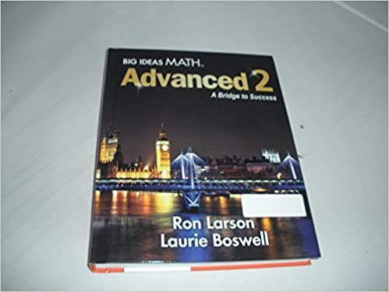

Edition: 2014

Science 7
Life Science for MS Student
Author: Christian Schools International
Publisher: Christian Schools International
ISBN#: 9780874630251
Required
