8th Grade Book List 2023-2024
(8th grade can use digital books.)

Bible 8
Route 66
Author: Reed
Publisher: Positive Action for Christ
2006 Edition
Hard copy version-must be new or used by the student in Bible 6.
ISBN#: 9781595571090
or
Digital version
https://positiveaction.org/store/group/route-66
Student Manual-digital (PDF)
Required

This is the same book used in Bible 6 and Bible 7.

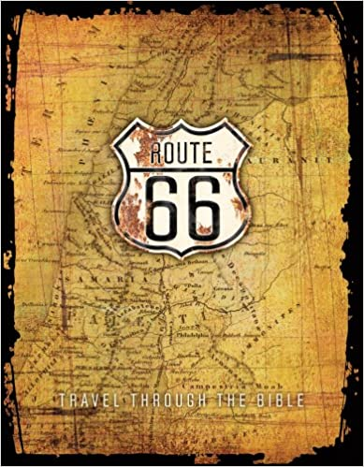

Humanities 8

The Witch of Blackbird Pond
Author: Speare
Publisher: Houghton Mifflin
Edition: 2011
ISBN#: 9780547550229
Required-Summer reading

Discovering Our Past: A History of the United States
Author: MHE
Publisher: McGraw Hill
Edition: 2018
ISBN#: 9780076680504
Required

The Brook Hill Writing Guide
Author: Travis
ISBN#: 978-1475225761
Required-will use grades 6th-12th

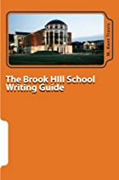

Pilgrim’s Progress
Author: Bunyan
Publisher: Aneko Press
Edition: 2014
ISBN#: 9781622452392
Required
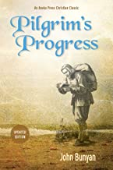

Narrative of the Life of Frederick Douglass
Author: Douglass
Publisher: New American Library/Penguin
Edition: 2005
ISBN#: 9780451529947
Required

Rifles for Watie
Author: Keith
Publisher: Harper Collins
Edition: 1987
ISBN#: 9780064470308
Required

To Kill A Mockingbird
Author: Lee
Publisher: Harper Collins
Edition: 2002
ISBN#: 9780060935467
Required

A Raisin in the Sun
Author: Hansberry
Publisher: Vintage Books
Edition: 1994
ISBN#: 9780679755333
Required

Animal Farm
Author: Orwell
Publisher: New American Library
Edition: 1994
ISBN#: 9780451526342
Required

Spanish 8

**Codes for the E-text book will be given in class by the teacher.

Math 8

Essentials of Algebra

**Essentials of Algebra students will have a curriculum given to them in class; there is not an outside book for this class.

Algebra 1-8
OPTIONAL (hard copy)
Big Ideas Math: Algebra 1: Texas Edition
Author: Houghton Mifflin
Publisher: Houghton Mifflin
Edition: 2015
ISBN#: 9781608408146
*Codes for the E-book will be given in class by the teacher

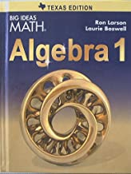

Science 8

Physical Science
Author: Elmer/Ferrier
Publisher: Christian Schools International
Edition: 2nd
Etext ISBN#: 9781935876397
Required
*We will have class a class set available for student use at school.

