AP Humanities 11 Book List 2023-2024
( Textbooks may be digital copies. Novels must be physical copies.)

AP Humanities 11

Fahrenheit 451
Author: Bradbury
Publisher: Simon & Schuster
Edition: 2013
ISBN#: 9781451673319
Required-Summer Reading
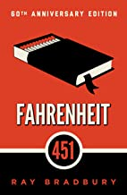

Mayflower: Voyage, Community, War
Author: Nathaniel Philbrick
Publisher: Penguin Books
ISBN# 9780143111979
Required-Summer Reading

US History
Author: Corbett
Publisher: OpenStax College
Edition: 2014
ISBN#: 9781938168369
OPTIONAL book to purchase Available online for FREE!

The Brook Hill Writing Guide
Author: Travis
ISBN#: 978-1475225761
Required-will use for grades 6th-12th grades
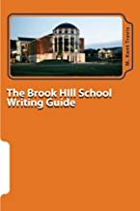

The Great Gatsby
Author: Fitzgerald
Publisher: Simon & Schuster
Edition: 1953
ISBN#: 9780743273565
Required

The Scarlet Letter
Author: Hawthorne
Publisher: Norton & Company
Edition: 2nd-2017
ISBN#:9780393264890
Required

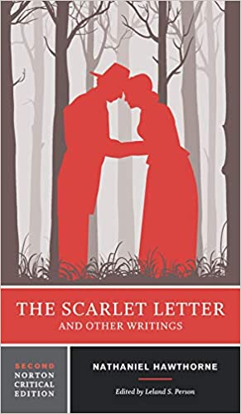

The Adventures of Huckleberry Finn
Author: Twain
Publisher: Penguin Classics
Edition: 2014
ISBN#: 0143107321
Required
(Check ISBN#...new version this year)

