Algebra 3 Book List 2023-2024

Algebra 3

** Required online access. Information about purchase will be emailed by instructor.

OPTIONAL:
Pearson: Algebra & Trigonometry
Author: Blitzer
Edition: 7th 2022

ISBN#: 9780136922179
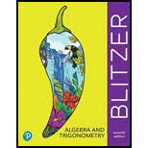

Big Ideas Math: Algebra 2: Texas Edition
Author: Houghton Mifflin
Publisher: Houghton Mifflin
Edition: 2015
ISBN#: 9781608408160
OPTIONAL

