Business Principles Book List 2023-2024

Course: Business Principles
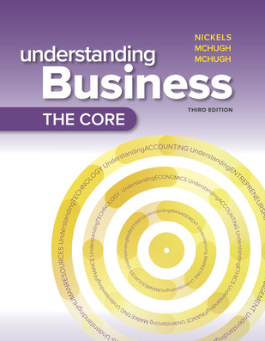

Title: The Core: Understanding Business (2024) “Connect”
Author: Nickles, McHugh, and McHugh
Publisher: McGraw Hill
Edition: 3rd Edition
ISBN: 978-1-26-673612-4
Notes: Required Connect online only (instant access resource).

Please wait to purchase close to the start of the semester that you are registered for, so that your digital access will last all semester long. This ONLINE Resource MUST be purchased from McGraw-Hill in order to receive the negotiated pricing of $52.00.

Please DO NOT order the physical textbook, or an older edition. Students must have the online digital courseware called CONNECT for The Core Understanding Business 3rd edition.

PURCHASE INSTRUCTIONS
This is a new resource and the textbook publisher is currently working on a internet based “store front” for you to process your order. As soon as the store front is available, Mrs. King will publish that information via email and canvas.

