ELL Book List 2023-2024

ELL

Ancient World History: Patterns of Interaction
Author: Beck/Rogers
Publisher: Holt, Rineart & Winston
Edition: 2012
ISBN#:9780547491134
Required
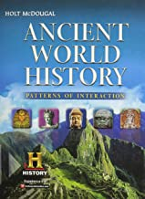

Fundamentals of English Grammar
Author: Azar
Publisher: Prentice Hall
Edition: 4th-2011
ISBN#:9780132469326
Required-MUST BE NEW
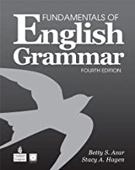

Vocabulary Power Plus: Vocabulary, Reading and Writing
Level 6
Author: Reed
Publisher: Prestwick House
Edition: 2013
ISBN#: 9781620190142
Required-MUST BE NEW
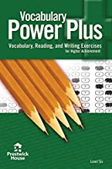

English Standard Version (ESV) Bible
Students will need an ESV Bible. They may have a digital version, an ESV study Bible, or any other ESV Bible.

