English 12 Book List 2023-2024
(Textbooks may be digital copies. Novels must be physical copies.)

English 12

The Things They Carried
Author: O’Brien
Publisher: Houghton Mifflin
Edition: 1990
ISBN#: 9780618706419
Required-Summer reading
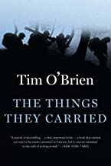

The Brook Hill Writing Guide
Author: Travis
ISBN#: 978-1475225761
Required-will use grades 6th-12th
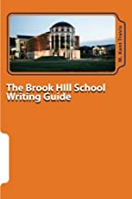

Oedipus Tyrannus
Author: Sophocles
Publisher: Hackett Publishing Company
Edition: 2000
ISBN#: 9780872204928
Required-English 12 and DC/AP English 12
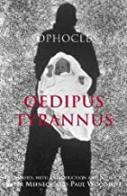

The Old Man and The Sea
Author: Hemingway
Publisher: Scribner
Edition: 1995
ISBN#: 0684801221
Required
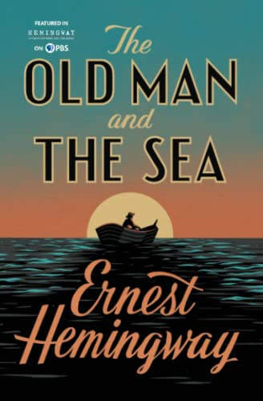

Hamlet: No Fear Shakespeare (graphic novel)
Author: Shakespeare
Publisher: Spark Publishing Group
Edition: 2008
ISBN#: 9781411498730
Required
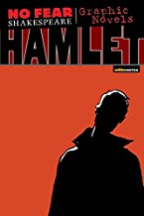

You Want Me to Read What?
Author: Travis
Publisher: Amazon
ISBN#: 9781461175421
Required

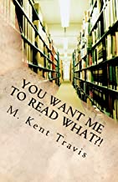

A World in Words: The World-Building of Writing an Academic Essay
Author: Travis
Publisher: Nacscorp
Edition: 2016
ISBN#: 9781535421768
Required
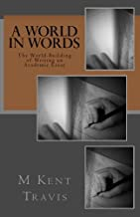

The Arrival
Author: Tan
Publisher: Scholastic Inc.
Edition: 2006
ISBN#: 9780439895293
Required

ESV Scripture Journal: Genesis
Publisher: Crossway
Edition: 2019
ISBN# 1433546299
Required

