Honors Humanities 9 Book List 2023-2024
(Textbooks may be digital copies. Novels must be physical copies.)

Honors Humanities 9

The Epic of Gilgamesh
Author: Anonymous
Translator: N.K. Sandars
Publisher: Penguin
ISBN#: 014044100X
Required-Summer Reading
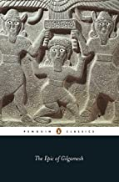

West in the World
Author: Sherman
Publisher: McGraw Hill
Edition: 5th-2014
ISBN#: 9780073407036
Required-will use for 9th and 10th grade Humanities

The Brook Hill Writing Guide
Author: Travis
ISBN#: 978-1475225761
Required-will use for grades 6th-12th
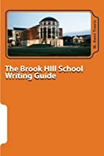

Essential Odyssey
Author: Homer (Lombardo/translation)
Publisher: Hackett Publishing Company
Edition: 2007
ISBN#: 9780872208995
Required
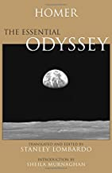

Essential Aenid
Author: Virgil (Lombardo/translation)
Publisher: Hackett Publishing Company
Edition: 2006
ISBN#: 9780872207905
Required
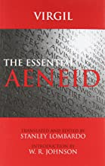

On the Incarnation
Author: St. Athanasis (Behr/translation)
Publisher: St. Vladimir’s Seminary Press
Edition: 2nd-2001
ISBN#: 9780881414271
Required
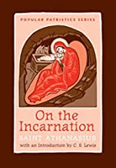

Five Dialogues
Author: Plato (Grube/translation)
Publisher: Hackett Publishing Company
Edition: 2nd-2002
ISBN#: 9780872206335
Required
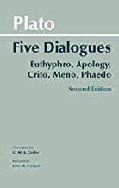

English Standard Version (ESV) Bible
Students will need an ESV Bible for Humanities 9 and 10. They may have a digital version, an ESV study Bible, or any other ESV Bible.

