Humanities 11 Book List 2023-2024
(Textbooks may be digital copies. Novels must be physical copies.)

Humanities 11

Fahrenheit 451
Author: Bradbury
Publisher: Simon & Schuster
Edition: 2013
ISBN#: 9781451673319
Required-Summer Reading
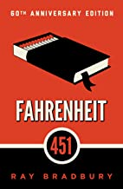

US History
Author: Corbett
Publisher: OpenStax College
Edition: 2014
ISBN#: 9781938168369
OPTIONAL book to purchase
Available online for FREE!

The Brook Hill Writing Guide
Author: Travis
ISBN#: 978-1475225761
Required-will use for grades 6th-12th grades
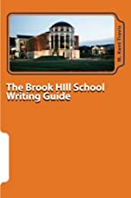

The Great Gatsby
Author: Fitzgerald
Publisher: Simon & Schuster
Edition: 1953
ISBN#: 9780743273565
Required for Humanities 11

The Scarlet Letter
Author: Hawthorne
Publisher: Penguin Classics
Edition: 2015
ISBN#: 0143107666
Required
(Check ISBN#...new version this year)

The Adventures of Huckleberry Finn
Author: Twain
Publisher: Penguin Classics
Edition: 2014
ISBN#: 0143107321
Required
(Check ISBN#...new version this year)

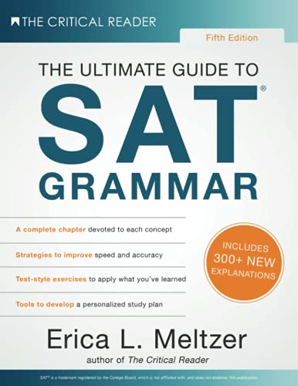

The Ultimate Guide to SAT Grammar
Author: Eric Meltzer
Publisher: The Critical Reader
Edition: Fifth (2019)
ISBN#9781733589536
Required

