Macroeconomics Book List 2023-2024

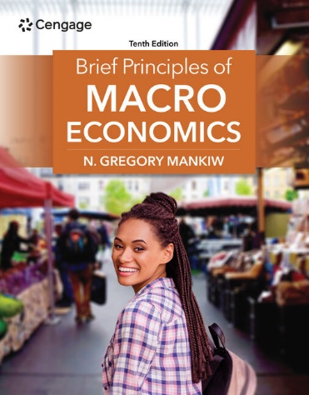
Course: Macroeconomics (CP, DC, AP)

Title: Brief Principles of Macroeconomics, Mindtap
Author: Mankiw
Publisher: Cengage
Edition: 10th Edition
ISBN: 9798214039282 / 8214039282
Notes: Required Mindtap online only (instant access resource).

Please wait to purchase close to the start of the semester that you are registered for, so that your digital access will last all semester long. This ONLINE Resource MUST be purchased from Cengage in order to receive the negotiated pricing of $50.00.

PURCHASE INSTRUCTIONS: Note there are three different “codes”:
  - Master Case #
  - Access Code
  - Course Key
- Call Cengage at 888-915-3276. (Tip to reduce hold times over the phone: Call early weekday mornings, 7-8am, as early in the semester as possible to reduce hold times).
- Reference Master Case # 08195992. Use your credit card over the phone to place your order (Cengage no longer accepts web orders).
- Receive purchase confirmation email from Cengage with your unique “Access Code.” Follow email instructions to go online, set up or log in to your Cengage account, use your access code to have the textbook loaded into your online dashboard.
- Click on textbook and find the area where you can enter the teacher’s “Course Key.” This will give you specific access to the course Mrs. King has set up and your name will then register in her Cengage Gradebook. Mrs. King will give you the “Course Key” via email and canvas right before the semester begins.

