Medieval and Modern Philosophy - Booklist 2023-2024

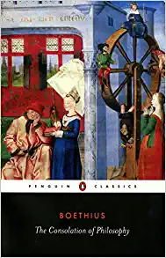
The Consolation of Philosophy
Author: Boethius (Victor Watts translation)
Publisher: Penguin Classics
Edition: 1999
ISBN#: 978-0140447804
Required

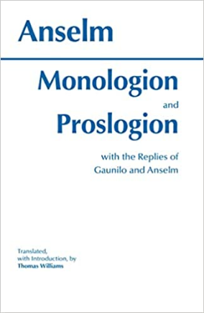
Monologion and Proslogion
Author: Anselm (Thomas Williams translation)
Publisher: Hackett Publishing Company
Edition: 1996
ISBN#: 978-0872202979
Required

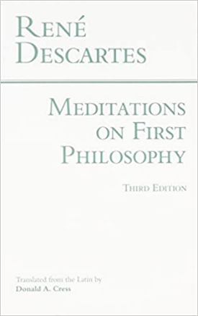
Meditations, Objections and Replies
Author: Descartes (Donald Cress translation)
Publisher: Hackett Publishing Company
Edition: 1996
ISBN#: 978-0872201927
Required

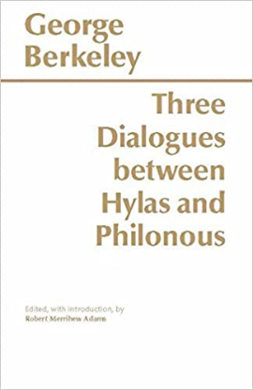
Three Dialogues Between Hylas and Philonous
Author: Berkeley (Robert Adams / editor)
Publisher: Hackett Publishing Company
Edition: 8th Printing Edition (1979)
ISBN#: 978-0915144617
Required

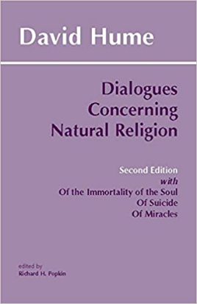
Dialogues Concerning Natural Religion
Author: Hume (Richard Popkin / editor)
Publisher: Hackett Publishing Company
Edition: Second Edition (1998)
ISBN#: 978-0872204027
Required

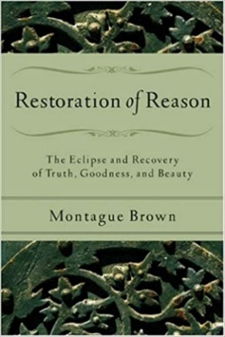
The Restoration of Reason
Author: Montague Brown
Publisher: Hackett Publishing Company
Edition: First Edition (2006)
ISBN#: 978-0801031540
Required

