Practical Politics Book List 2023-2024
(Digital book may be purchased, if available)

Practical Politics

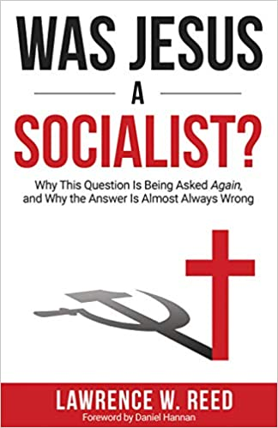

Was Jesus a Socialist?
Author: Reed
Publisher: ISI Books
Edition: 2020
ISBN#: 1610171608
REQUIRED

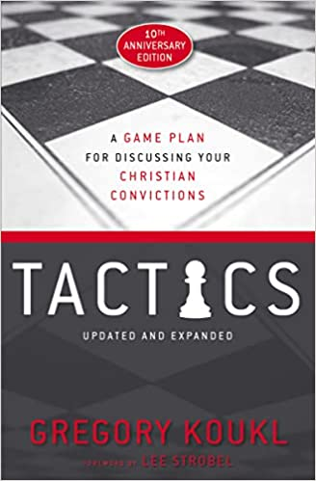

Tactics, A Game Plane for Discussing Your Christian Convictions
Author: Koukl
Publisher: Zondervan
Edition: 2019
ISBN#: 978-0310101468

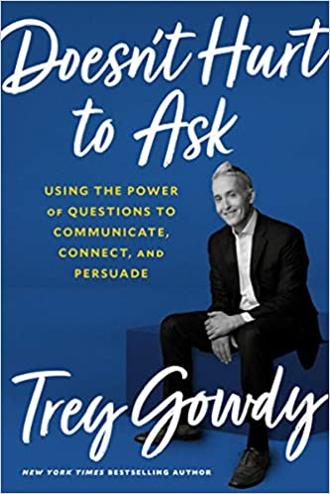

Doesn’t Hurt to Ask
Author: Gowdy
Publisher: Forum Books
Edition: 2020
ISBN#: 978-0593138915

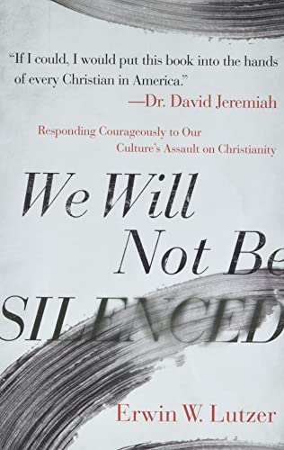

We Will Not be Silenced
Author: Lutzer
Publisher: Harvest House Publishers
Edition: 2020
ISBN#: 978-0-7369-8179-8

Rules for Radical Defeated
Author: Hedgpeth
Publisher: CreateSpace Independent Publishing
Edition: 2012
ISBN#: 1475192037

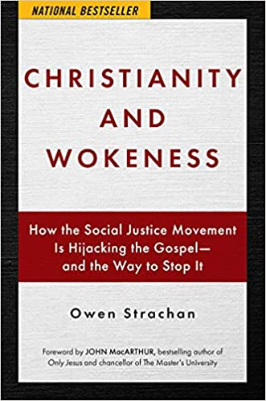

Christianity and Wokeness
Author: Strachan
Publisher: Salem Books
Edition: 2021
ISBN#: 9781684512430

Fault Lines
Author: Baucham Jr.
Publisher: Salem Books
Edition: 2022
ISBN#: 978-1684513284

Black Eye for America
Author: Swain
Publisher: Be the People Books
Edition: 2021
ISBN#: 978-1737419808

