Statistics Book List 2021-2022

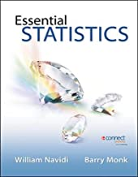
Statistics
**Required online access.
Information about purchase will be
emailed by instructor.

OPTIONAL:
Essentials Statistic with Data CD and Formula Card
Author: Navidi/Monk
Publisher: eConnect
Edition: 1st

ISBN#: 978-0-0777-0140-6

