US History Book List 2023-2024
(Digital books may be purchased, if available)

US History

Making America, Volume 1
Author: Berkin
Publisher: Cengage
Edition: any
ISBN#: 9781285194806
OPTIONAL
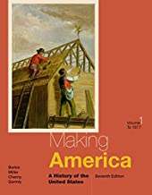

Making America, Volume 2
Author: Berkin
Publisher: Cengage
Edition: any
ISBN#: 9781285194813
OPTIONAL
