Sports Management Book List 2023-2024

Course: Sports Management
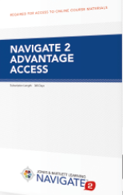
Title: Principles and Practice of Sports Management (2019)
Author: Masteralexis, Barr, and Hums
Publisher: JB Learning
Edition: 6th Edition
ISBN: 9781284142167
Notes: Navigate 2 Advantage (Digital) Access Required

When the semester begins, go to https://www.jblearning.com/catalog/productdetails/9781284142167. DO NOT PURCHASE THE 365 Day eBook or 135 Day eBook as students will not have access to the online content we will use in the course. Use coupon code BROOKHILL for 25% off the listed price. The access will be sent to the email in checkout immediately, with instructions on how to redeem the access. Once the access code is redeemed and an account is created, the access length starts, therefore PLEASE WAIT until the semester starts to redeem the code!

